**SETUP GUIDELINE**

**Group DUNGNT**

**By QuanBTSE02034**

**SOFTWARES:**

* *eclipse-php-helios-SR2-win32-x86_64*
* *xampp-win32-1.8.3-4*
* *jdk-8u5-windows-x64*

**WINDOW : Window 7**

**SYSTEM TYPE : 64-bit OS**

**SETUP STEPS:**

1. **jdk-8u5-windows-x64** setup
2. *Open*file **jdk-8u5-windows-x64**. Choose **Next >**

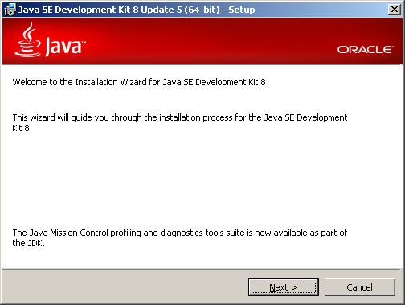

1. Choose **Next >**

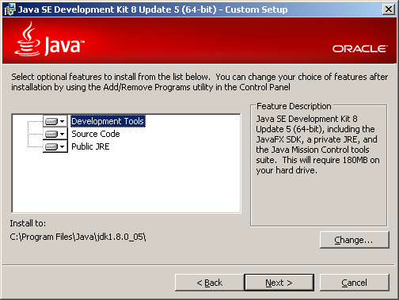

1. Wait some seconds... Choose **Next >**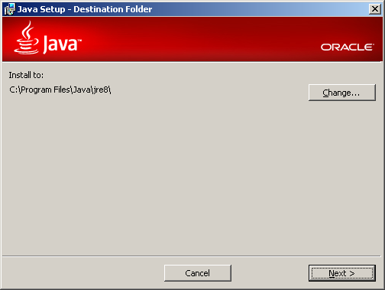
2. Finished. Choose **Close**

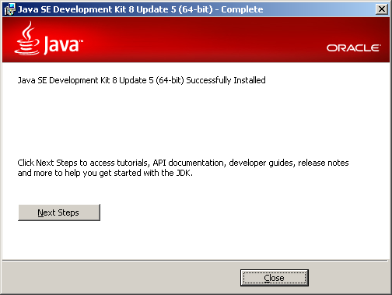

1. Find the folder bin in jdk1.8.0_05 and copy the link to folder bin. Example : *C:\Program Files\Java\jdk1.8.0_05\bin*
2. *Right mouse click* on **My Computer** iconand choose **Properties**

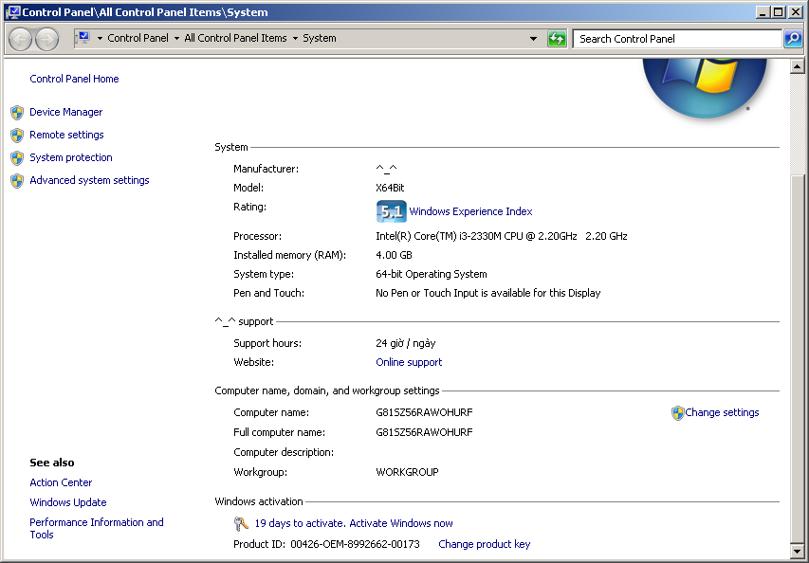

1. Choose **Advance systems settings**

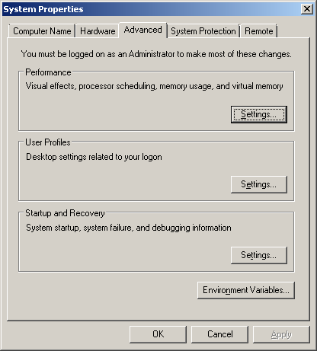

1. Choose **Environment Variables...**

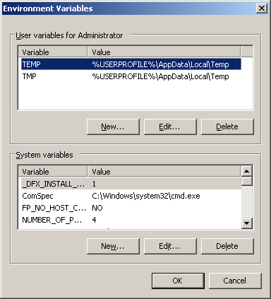

1. Find value **Path** in **System variables** and *edit* it

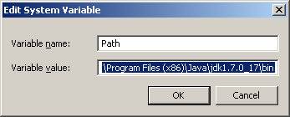

1. Type “**;”** at the end of **Variable value** then *paste* link to folder bin at step 5 and choose **OK** to *apply* the changes

Example:

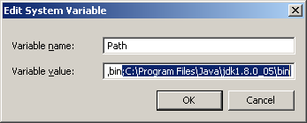

1. *xampp-win32-1.8.3-4* setup
2. *Open* file **xampp-win32-1.8.3-4-VC11-installer.exe**. Then choose **Next >**

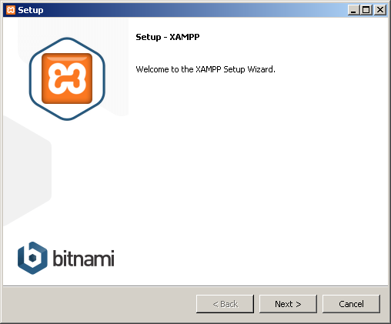

1. Choose **Next**

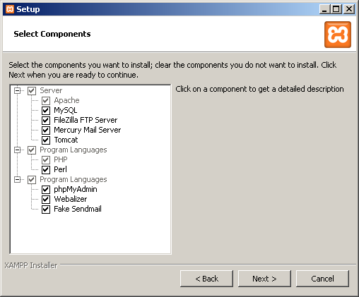

1. *Select* folder to install **XAMP** then choose **Next**

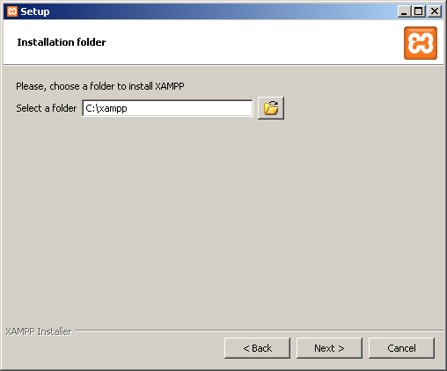

1. Choose **Next** then Choose **Next**

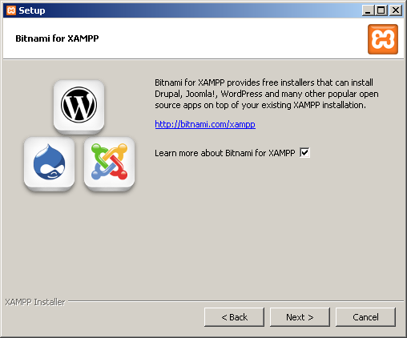

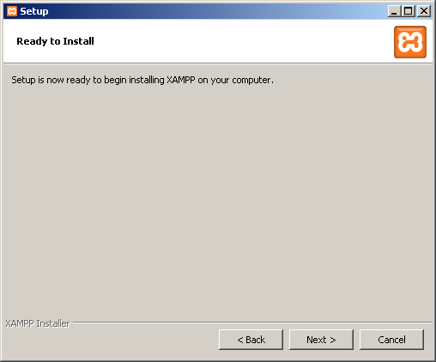

1. Choose **Finish**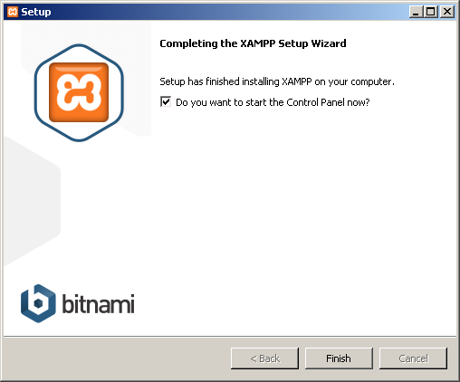
2. **eclipse-php-helios-SR2-win32-x86_64** setup
3. *Extract* file **eclipse-php-helios-SR2-win32-x86_6**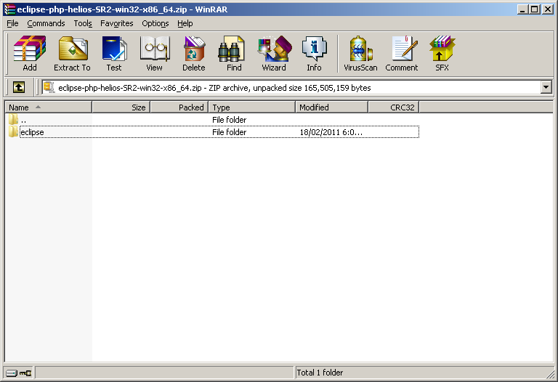
4. *Run* file **eclipse.exe** in **eclipse** file. Choose **Browse...** and link to folder *xampp\htdocs*. Then choose **OK**

Example: 